# **The test programme user guide**

**The “Initial money” is your money in Oystal card.**

**In this programme, the value is £30.**

**The “Current money” is your money in Oystal card after the trip.**

**If you start tip, click “Add channel”.**

**You can see this dialog.**

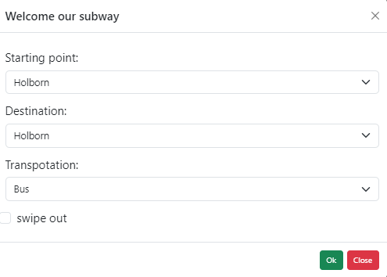

**You can select appropriate content that you want.**

## Note: “swipe out” is the state of swipe out.

## Warning: station point should not be the same as destination.

If you select content, then click “Ok”.

You can see that the current money is changed.

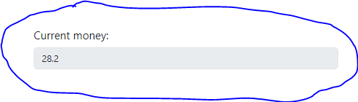

And you can see the information about your trip.